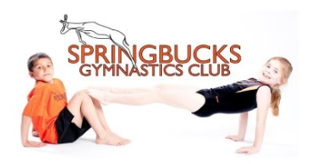
Training gymnasts
since 2009

Welcome to

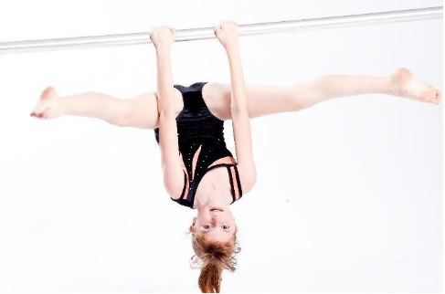
Hi! We are Springbucks Gymnastics Club, an Independent Gymnastics Affiliation Club, who have been running top class gymnastics sessions in schools around South Bucks since 2009. Since September 2025 we have also been running Friday morning sessions before school at Widmer End Combined Primary.
The club is run by Ruth Middleton and Fenella Lockhart and a team of highly qualified and experienced coaches who love gymnastics and are enthusiastic about introducing children to our sport and helping them develop their skills and achieve their goals.
‘It is so fun and you learn new skills that you never knew you could do!’ Molly
‘I love gymnastics because all the activities are amazing and the coaches make it fun, memorable and challenging. It is an amazing experience and I recommend it! 5 star experience!!!’ ☺ Skye
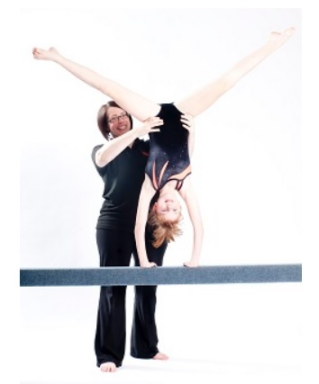
We are a welcoming and friendly recreational club, focused on growing children’s self confidence as they develop their agility, balance and coordination, strength and flexibility whilst moving through a progressive and motivational awards scheme. Our sessions introduce gymnasts to skills on floor, air track, beam, bars, trampette and vault in a safe, fun and progressive manner and many of our gymnasts stay with us from Reception right through to Year 6 because they love it so much!
‘I love gymnastics and the opportunities that we are given are amazing and it teaches us lots of important skills!’ Poppy
Classes are £11 per week for the 1 hour session (Fridays 7.45 – 8.45am) and we offer an Earlybird booking discount each returning term as well as a soft start between 7.45 – 8am for those who are not so good at getting up in the mornings! There is also a £30 annual membership for insurance and personal accident cover.
We have some spaces remaining at club next year and we will be offering a free taster session in September to give children the chance to see if they enjoy gymnastics and would like to join.

EMAIL US TODAY AT SPRINGBUCKSGC@GMAIL.COM TO BOOK YOUR CHILD IN FOR A FREE TRIAL SESSION ONE FRIDAY BEFORE SCHOOL OR COME ALONG TO ANY OF OUR FABULOUS HOLIDAY CAMPS AT HAZLEMERE YOUTH CENTRE THIS SUMMER THAT ARE OPEN TO CHILDREN AGED 3 – 11 OF ALL ABILITIES! VISIT WWW.SPRINGBUCKS.CO.UK FOR MORE INFORMATION TODAY.

